

Good Documentation Practices

Standard Operating Procedure

Purpose

The purpose of this work instruction is to define the best documentation practices for completing and making corrections to quality records at SILQ.

Paperwork produced is of equal importance to product produced. Using good documentation practices (GDP) ensures that entire processes can be reconstructed from historical records.

Scope

This work instruction applies to all SILQ personnel who fill out quality records, including forms, logs, and scientific laboratory notebooks.

Documents

Reference Documents

QM.SLQ001 Document Control

21 CFR Part 820 (Subpart M – Records)

ISO 13485:2016 (Section 4.2 Documentation Requirements)

Appendices / Associated Forms / Templates

Appendix 1 Examples of Correct and Incorrect Documentation Practices

Definitions

Abbreviations / Acronyms

GDP: Good Documentation Practices

N/A: Not applicable

General Definitions

Back-Dating: Writing an earlier date associated with an earlier event (such as the performance of work or review of work) rather than the current date.

Good Documentation Practices: A set of activities that enable the recording of raw data and other handwritten entries in a legible, traceable, and reproducible manner.

Indelible Ink: Writing ink that cannot be erased or washed away. Gel pens and markers do not use indelible ink.

Not Applicable: Term used to document a section or area on a form that is not applicable, for which the information requested was irrelevant in that particular instance.

Quality Record: Any record required for demonstrating compliance with 21 CFR 820 and ISO 13485.

Responsibilities

It is the responsibility of all SILQ employees and subcontractors/consultants to comply with the requirements of this procedure when completing any quality record, form, log, or scientific laboratory notebook entry.

Quality Assurance management is responsible for ensuring compliance with this document by SILQ personnel and sub-contractors/consultants.

Procedure: Initial Entry of Information

Write only in black or blue indelible ink.

Write legibly.

Do not use a hash, cross, or slash mark when writing the digits 7 or 0, because this may be mistakenly interpreted as crossing out the number.

Sign or initial for work or review you performed. Do not sign or initial for another person.

Document everything when it happens, to ensure accuracy.

Do not record data, form entries, or log entries on sticky notes or other temporary material.

Use the “DD Mmm YYYY” format for date entries, as in 13 Aug 2018 or the “MM/DD/YYYY” format, as in 08/13/2018. (Dates incorporated into product labeling may be subject to other regulations or conventions, so need not follow this instruction.)

Contract Manufacturing Organizations may use their own date format in accordance with their own internal procedures.

All fields on forms and logs must be filled out completely. Blank fields can be interpreted as missing data and empty spaces could allow someone the opportunity to add information without your knowledge or consent.

If there is no data to enter in a designated spot, enter “N/A” for not applicable.

If an entire section is not applicable:

Strike through the section with a single diagonal line.

Enter “N/A” on the line.

Initial and date on the line.

When the same data must be recorded in a column or row 3 or more consecutive times:

If the data is collected over time, write out every entry individually, as it is collected.

If the repetition is expected (for example, if it’s part of an experimental design), the writer may choose to do the following instead of writing out every entry:

Record the data in the first space that it occurs on the column or row.

Draw a single arrow from the first space to the last space where the entry occurs, traversing the spaces in between.

Record the repeated data in the last appropriate space in the column or row.

Do not use ditto marks (“) to imply repetitive data.

When information is recorded on the reverse of a page, make a notation on the front of the page referencing the back page.

Abbreviations may only be used if they have been defined at their first use in the document, e.g. “Good Documentation Practices (GDP)” defines “GDP”, as does describing an abbreviation in an early Definitions section.

Procedure: Correcting Errors and Omissions

Original information must remain legible.

Use of white out or correction tape is prohibited.

Write overs and obliterations are unacceptable.

To make a correction:

Draw a SINGLE line through the incorrect information.

Line out the entire entry, not just individual characters or digits that are incorrect.

Write the correction near the original entry.

Initial and date the correction with the date the correction was made.

The following is an example of a proper correction: 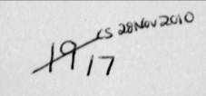

If the reason for a correction is not obvious or is a change in data, write a brief explanation near the correction documenting the reason or justification for the correction.

If there is not enough space nearby, use a circled number to identify the correction and then record the explanation as a footnote at the bottom of the page or in some other appropriate space on the document. (Start with a circled 1, and for subsequent notations continue the sequence with 2, 3, 4, etc.)

Initial and date the explanation.

Data may be transcribed from an original data record. However,

The original record must be maintained if possible.

The location of the original record must be referenced on the transcribed document.

Back-dating a record is strictly prohibited. If a record is amended or changed at a later date, document the actual date of the change on the record.

To correct an omission:

If information is missing or supplemental information must be added:

Enter the information, provide an explanation, and identify the primary source for the information.

Initial and date with the current date.

If the entry was not applicable, write “N/A” and initial and date with the current date.

If the original review of the document occurred prior to making a change, the change and explanation must be reviewed, and then initialed and dated by the reviewer.

Do not alter controlled documents or records without following required change control practices defined in QM.SLQ001 (Document Control).

Procedure: Scientific Laboratory Notebooks

All instructions in Sections 6 and 7 are equally applicable to Scientific Laboratory Notebook entries.

Obtain an official Scientific Laboratory Notebook from the Quality Assurance department.

The Quality Assurance department will keep a log for Scientific Laboratory Notebook issuance containing at least the following information: notebook number, individual receiving the notebook, and the date issued.

All Scientific Laboratory Notebooks must be identified with:

“SILQ” on the front cover

Notebook number on the front cover

Date of Issue on the front or back cover, inside front cover, or first page

Ownership by SILQ

Purpose of the notebook (e.g. research prototype testing)

Each page must include the following:

Notebook number

Page number

A title or brief description of the experiment or project contained on the page (no more than one allowed per page).

Date: The date the entry is recorded into the scientific laboratory notebook, preceding the entry.

Do not back-date.

Information from multiple dates may be recorded on a single page, but each time the new date must precede the associated entry.

If information is being entered on a different date than the completion of the work, write that this work was completed on DD Mmm YYYY (or MM/DD/YYYY).

When data from a single experiment or project is recorded on multiple pages, record on each page the page from which the work is continuing and the page where the work continues.

Signatures and Dates

When entries from different days are on a single page, each entry must be separated by a line signed and dated by the person recording the information.

Both the person entering the information and a witness who reviews and understands the information must sign and date each page upon its completion. (With his or her signature, the witness is verifying that they have reviewed and understood that page’s information.)

Changes to Original Information: If information is changed that has already been witnessed, the change must be reviewed and acknowledged by the original reviewer with a new signature and date.

Blank or Empty Space: Following the completion of each page, and prior to having the page witnessed, any portion of a page that is left blank should have a diagonal line drawn through the empty space and include “N/A” along with the initials and date, per Section 7.

Attachments: Attached forms, photographs, charts, statistical printouts, original records, etc., may be permanently attached (glued or taped) to the notebook pages.

After affixing the attachment, sign and date one of its borders, with a portion of the signature and date on the notebook and a portion on the attachment, as shown below.

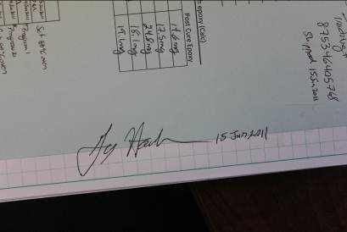

If an attachment is not an original record, its source must be clearly identified in a descriptive title.

For notebooks with single-sided pages, attachments may be pasted on the back side of each page. When doing so, assign the back side the same page number as the front side, with the front side page number appended with an “A” and initial/dated, and the back side labeled with the page number and “B” (or appended with a “B” and initial/dated, if a number is already printed on the back side).

Do not cut through an attachment’s information (e.g. words, numbers, or equations).

If the attachment cannot be created without cutting through information, include an explanation as to why this is acceptable, followed by a signature (or initials) and date.

If only a portion of a document is relevant to paste as an attachment (e.g. one section of a journal article or two columns of a table), no further explanation is required as long as the attached information is complete.

Attachments may be cut into smaller pieces and affixed to several pages if space constraints require it.

When photocopying SILQ Scientific Laboratory Notebooks:

Clearly mark “Copy” on all copied pages.

Clearly mark “SILQ” on all copied pages.

Copies should be of the entire page. If a copy cannot be created without cutting off information (e.g. for an enlargement), an explanation as to why this is permissible is required, with a signature (or initials) and date.

If referencing a page or pages of a SILQ Scientific Laboratory Notebook, be sure to also reference the notebook’s number.

Some examples of correct and incorrect documentation practices are included in Appendix 1.

Appendix 1 – Examples of Correct and Incorrect Documentation Practices

Example 1:

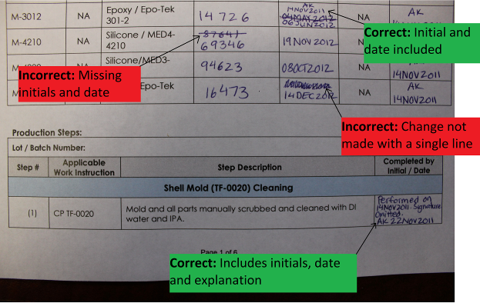

Example 2:

